Architectural Design Document

**Introduction**

With an aim to build a simplistic version of a Dungeons and Dragons role-playing game, we implemented a Model View Controller (MVC) architectural design model along with Observer pattern. It was an effort to use extreme programming effort with iterative software development approach to make a modular design and deliver several working coherent modules in small increments or builds.

**Model View Controller**

Model View Controller design aims at decomposing an interactive system into three components, namely: Model, View and Controller.

**Model** - The model represents data and the rules that govern access to and updates of this data. In enterprise software, a model often serves as a software approximation of a real-world process.

**View** - The view renders the contents of a model. It specifies exactly how the model data should be presented. If the model data changes, the view must update its presentation as needed. This can be achieved by using a push model, in which the view registers itself with the model for change notifications, or a pull model, in which the view is responsible for calling the model when it needs to retrieve the most current data.

**Controller** - The controller translates the user's interactions with the view into actions that the model will perform. In a stand-alone GUI client, user interactions could be button clicks or menu selections. Depending on the context, a controller may also select a new view -- for example, an action on a particular click event may result in rendering a completely new view.

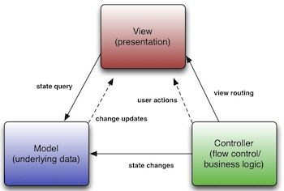

**Fig1. Basic MVC architecture**

As the figure 2 goes, this is how MVC has been implemented in the project.

* Various **Models** (mapModel, characterModel, etc) manages the behavior and data of the application domain. Once it gets a change state query request from the various Views (mapView, characterView, etc) that are registered to the model, they respond to instructions to change the state from various controllers (mapController, characterController, etc).
* Here we have built an event-driven system where the model notifies observers (usually views) which have been registered to the models, whenever there is change in information or state, so that they can react.
* **Views** on the other hand renders the model into a form suitable for visualization or interaction, in a form of UI (user interface). If the model data changes, the view must update its presentation as needed.
* Here we have developed a push model where view registers itself with the model for the change notifications, thus following observer pattern.
* **Controllers** are designed to handle user input and initiate a response based on the event by making calls on appropriate model objects. Thus accept various input from the user and instruct the model to perform operations.
* The controller translates the user's interactions with the view it is associated with, into actions that the model will perform that may use some additional/changed data gathered in a user-interactive view.
* Controller is also responsible for invoking new views upon conditions.

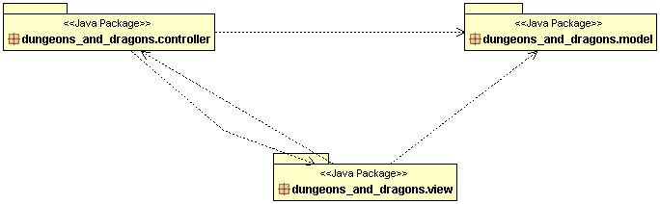

**Fig. 2 Class Diagram for overall MVC structure**

Following the layout of figure 2 the figure 3, 4 and 5 describe the actual class diagrams inside each and every packages. Viz. Model Package in figure 3, View Package in figure 4, Controller Package in figure 5.

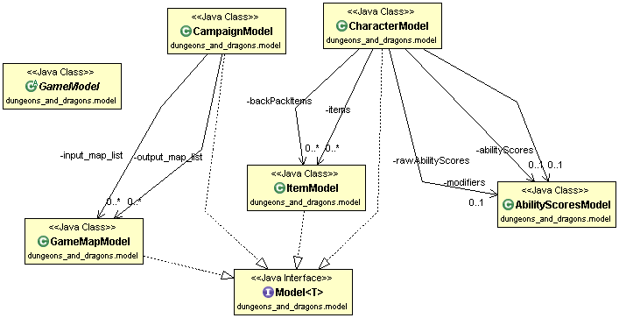

**Fig.3 Model Class Diagram**

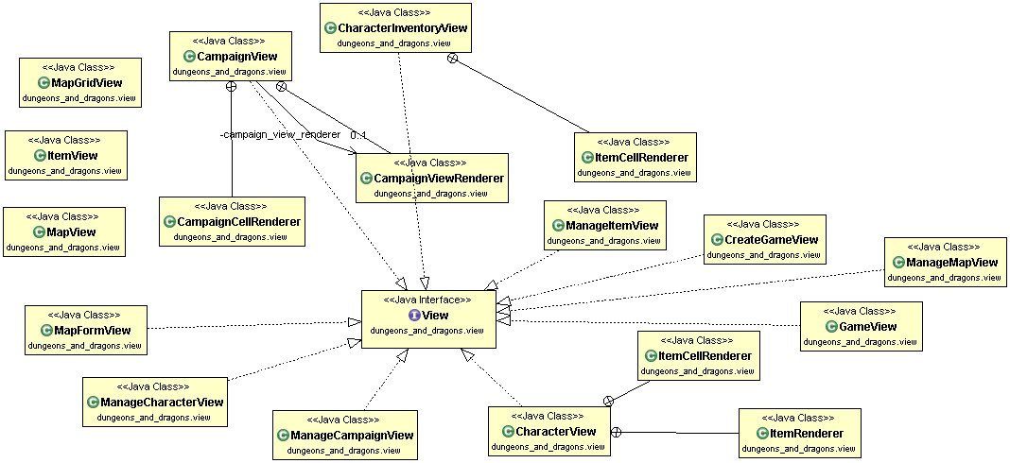

**Fig.4 View Class Diagram**

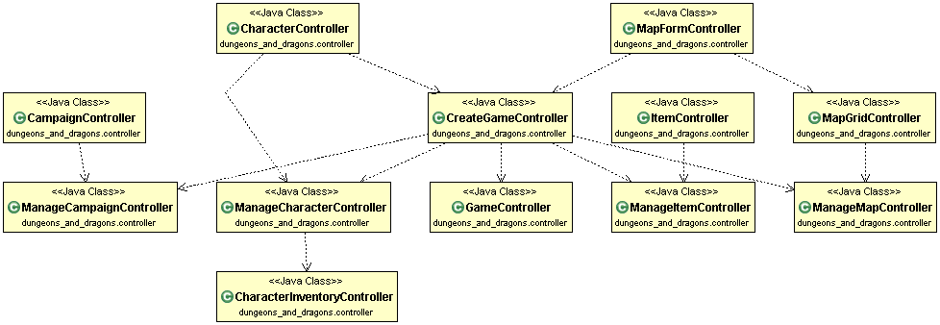

**Fig.5 Controller Class Diagram**

Figure 6 shows one particular class diagram (of many such possible class linkage possible) where in it is shown how MVC structure is implemented in the actual sense. With each and every package of model controller and view linking with each other in event-driven system.

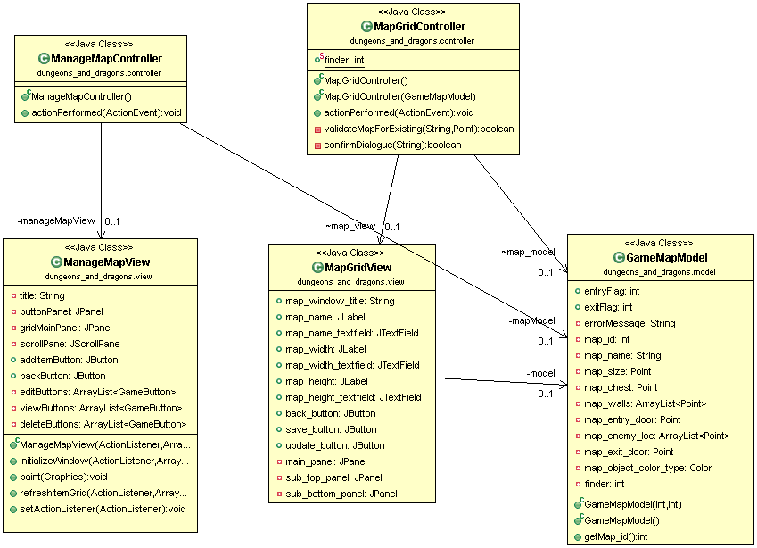

**Fig.6 Map architecture class diagram**

**References**

* <http://www.oracle.com/technetwork/articles/javase/index-142890.html>
* http://www.java-forums.org/attachments/ocmjea/3449d1333636384t-tutorial-review-web-tier-application-architecture-java-architect-exam-c5-conceptualmvc.jpg